1. No - Does $k(x, x') = sin(x) + x'$ describe a valid kernel?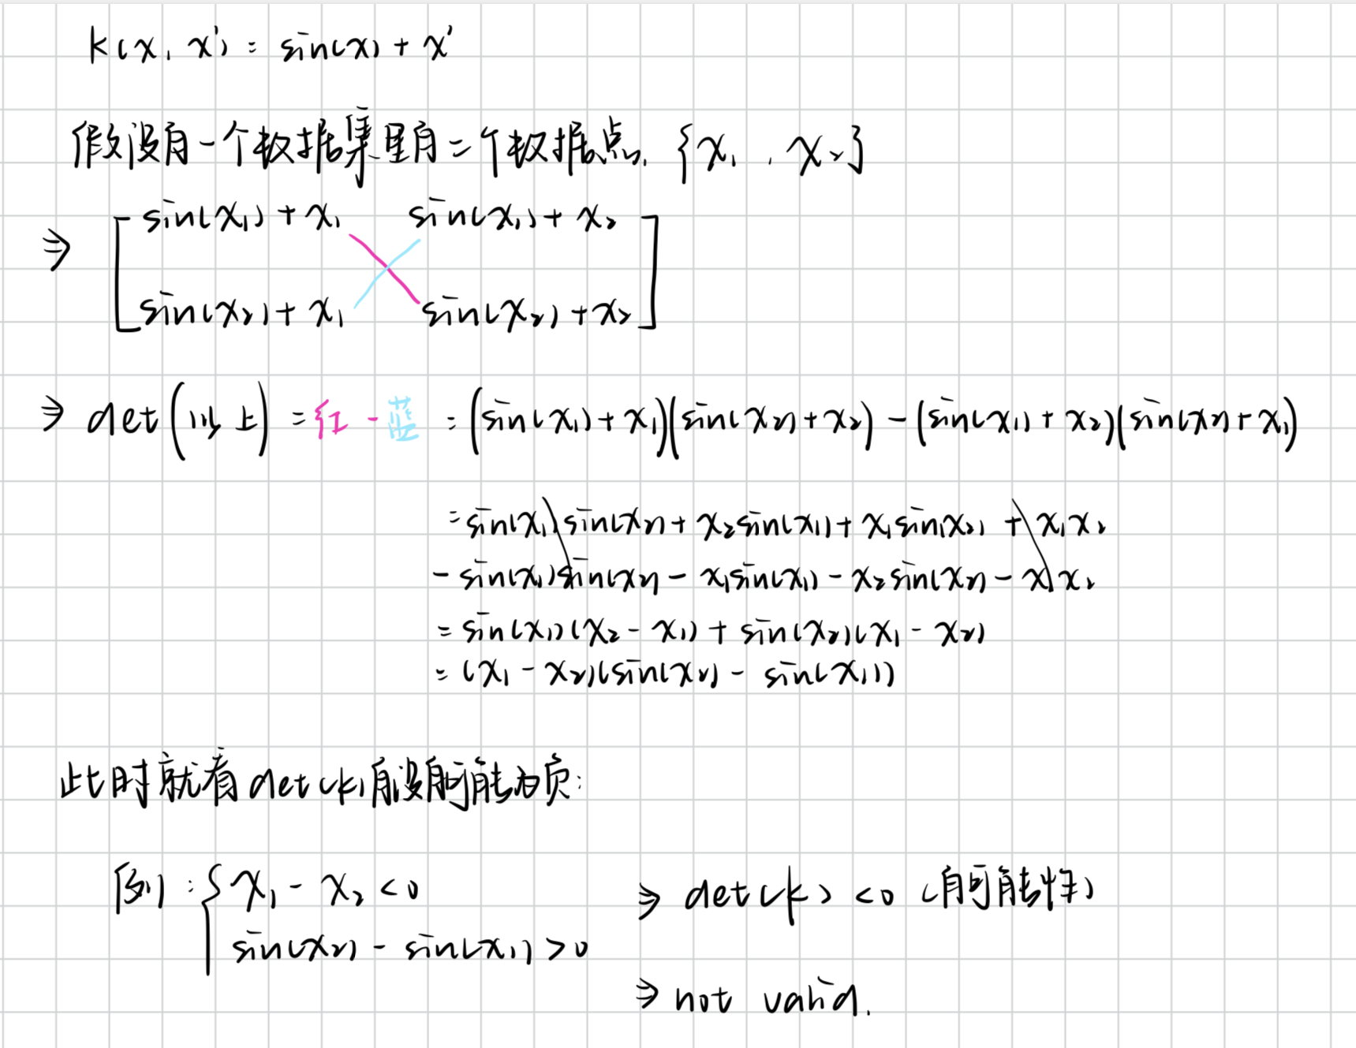
2. Given the function $f(x) = exp\frac{-x^{2}}{2⋅σ^{2}}$ parameterized by the length scale parameter. Assign the correct value of $σ$ to the figures (a), (b) and (c).

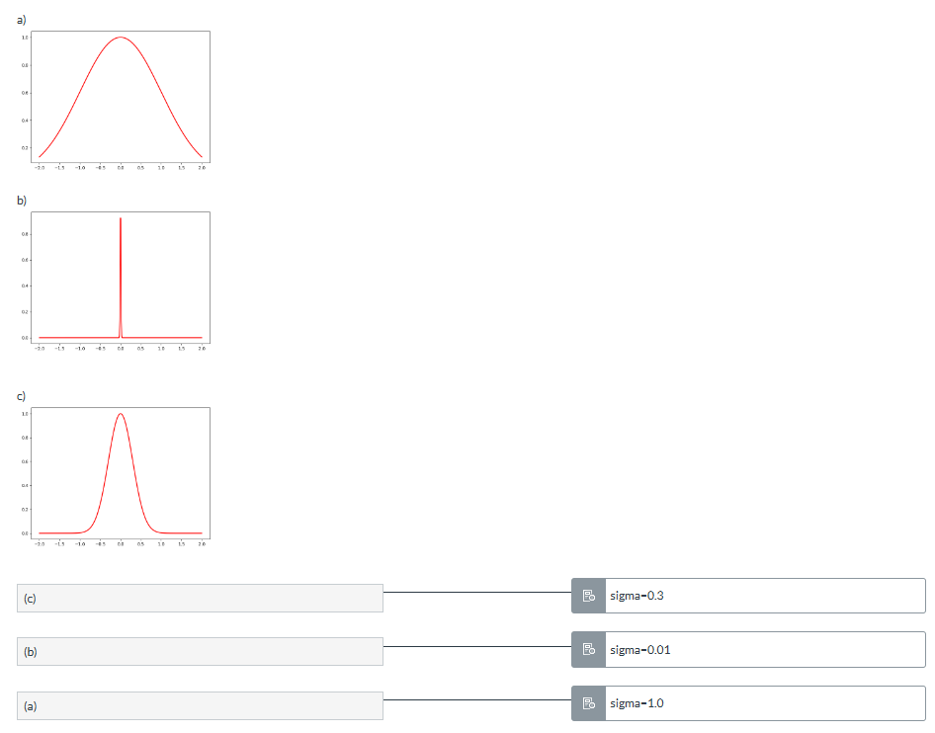

1. Yes - Assuming a constant $C > 0$, does $k(x,x') = C$ describe a valid kernel?

这里det(K) = 0,不小于0，所以ok

1. Which of the following statements are correct (recall the definition of a kernel in terms of a feature map and inner product)?

* Any symmetric function is a valid kernel $k(x,x')$
* If $k(x,x')$ is a kernel, then the kernel Gram matrix K is symmetric and positive semi-definite.
* A kernel function $k(x,x')$ can be decomposed into the inner product in some feature space, i.e. $k(x,x') =< ϕ(x), ϕ(x')>.$

1. Yes - Does $k(x,x') = e^{x+x'}$ describe a valid kernel?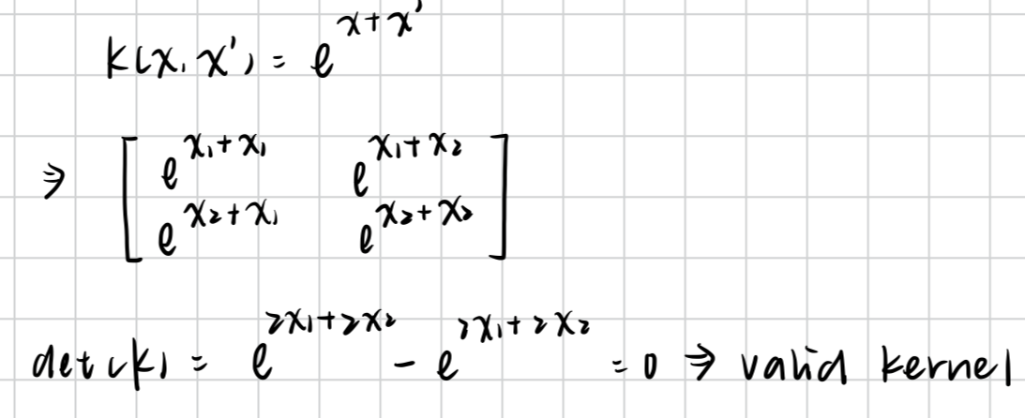
2. Yes - Given the matrix K below, is the function $k(a,b) = a^{t}Kb$ for $a,b ∈R^{2}$ valid kernel?

15-4 = 11 > 0

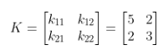

1. No - Given the matrix K below, is the function $k(a,b) = a^{t}Kb$ for $a,b ∈R^{2}$ valid kernel?

0 - 9 < 0



1. In the figures below you see the predictions of four linear kernel regression models with different kernels (with neglegibly small weight regularization!). Assign the correct kernel to each of the images (a), (b), (c) and (d)!

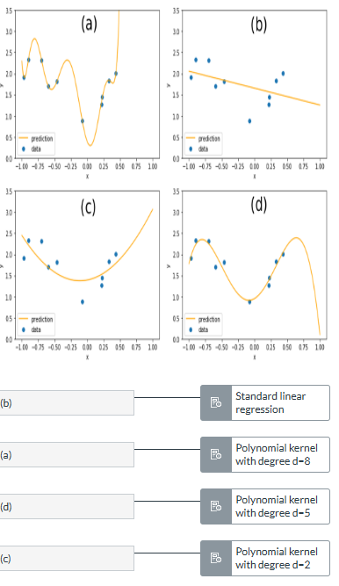

10. Which of the following statements are correct?

* It is possible to construct a new kernel by exponentiation of an existing kernel.
* The RBF/Gaussian kernel in linear regression can be shown to be related to a feature map to an infinite dimensional feature space.
* Kernels are non-negative functions (in the context of this module).
* The kernel trick can only be applied to regression algorithms.
* It is possible to construct a new kernel by addition of two existing kernels

11. No - Assuming a constant $C < 0, does$ $k(x,x') = C$ describe a valid kernel? 必须constant是正数才是kernel valid，

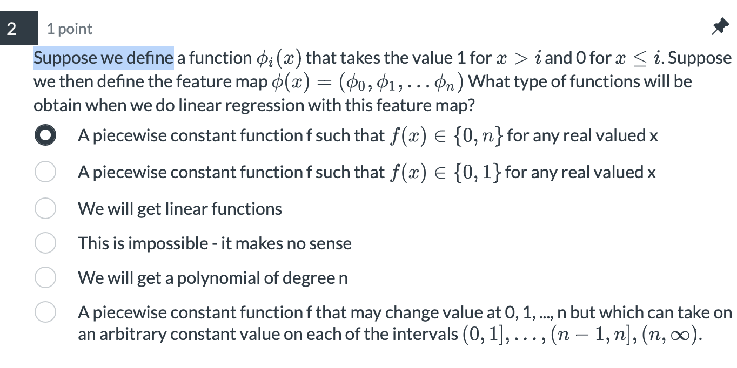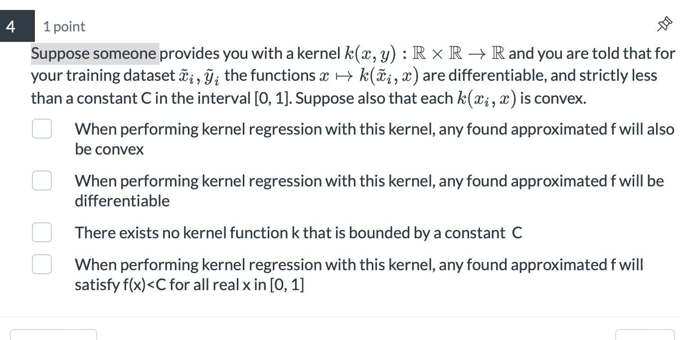

Suppose we define a function $ϕ_{i}(x)$ that takes the value 1 for x > i and 0 for x≤i. Suppose we then define the feature map $ϕ(x) = (ϕ_{0}, ϕ_{1},...ϕ_{n})$ What type of functions will be obtain when we do linear regression with this feature map?

1. A piecewise constant function f such that f(x)∈{0,n}for any real valued x
2. A piecewise constant function f such that f(x)∈{0,1}for any real valued x
3. This is impossible - it makes no sense
4. We will get linear functions
5. A piecewise constant function f that may change value at 0, 1, ..., n but which can take on an arbitrary constant value on each of the intervals (0,1],...,(n−1,n],(n,∞).
6. We will get a polynomial of degree n

